# Name :Sawan



# UID :23BCA10259

# Branch: BCA

# Section/Group : ~~4~~(A)

# Semester: 3**rd**

Subject Name: Desktop Publishing Lab



# Submitted to : Ms.Shivani Ma’am



Aim/Overview of the Practical:

D~~e~~sign a professional book cover(front & back).



Objective~~:~~ ~~D~~esign a professional bo~~o~~k  cove~~r~~ for "Business Studies 2024-202~~5~~" with emphasison busi~~n~~ess marketingstrategies.



Purpose: To c~~r~~eate a visu~~a~~lly appealing info~~r~~mative cov~~e~~rtha~~t~~ cap~~tu~~res thesu~~b~~ject's ess~~e~~nce and ~~a~~cademic value.



Task to be Done~~:~~



* D~~e~~sign a front and back c~~o~~ver for a Business ~~S~~tudies book.
* Includ~~e~~ key e~~l~~ements such as t~~h~~e title, author’ sname~~,~~ andrelevan~~t~~ imag~~e~~ry to re~~f~~lect t~~h~~e book~~’~~ s theme.



* Us~~e~~ Photoshop tools for layout, typography, coloradjustments,and addi~~n~~g images.



Algorithm:

Front Cove~~r~~ (1st Image)

1. Setup the Document Op~~e~~n Photoshop.



Go to Fi~~l~~e > New and ~~s~~et t~~h~~e document to A4 ~~s~~ize (8.27x



11.69 inch~~e~~s) with 300 DPI for print quality.

1. Create a Gradient Background



S~~e~~l~~e~~ct a light gray to wh~~it~~e gradient with ~~t~~he Gradient Tool.



Apply the grad~~i~~ent on t~~h~~e background l~~a~~yer to giveit aclean, professional look.



1. Add Diagonal Shapes



Us~~e~~ the Sha~~p~~e Tool or Polygonal Lasso Tool to  createdarkblue and purple diago~~n~~al sha~~p~~es inthe top left.



Lay~~e~~r and o~~v~~erlap these sh~~a~~pes for a dynam~~i~~c  design.

1. Add Circula~~r~~ Image Placeholders



Us~~e~~ th~~e~~ El~~l~~ip~~s~~e Tool to ~~c~~re~~a~~te two circles, ~~o~~ne above



th~~e~~other, as pla~~c~~eho~~l~~ders for images.



Import relevant ima~~g~~es(e.g., a h~~a~~ndshake,peo~~p~~le indiscussion).



Plac~~e~~ each image abo~~v~~e a circle layer, ~~t~~hen right- clickonthe ~~i~~ma~~g~~e layerand se~~l~~ec~~t~~ Create Clipping Mask to fit it w~~i~~th~~i~~n the cir~~c~~le shape.

1. Inse~~r~~t Text

Main Title ("BUSINESS STUDIES"):oUs~~e~~ th~~e~~ T~~e~~xt Tool to add "BUSINESS STUDIES." oChoose a bold, sans-~~se~~rif font,set ~~t~~he color todark~~b~~lue, and ~~m~~ake it ~~l~~arge a~~n~~d centered.



Yea~~r~~ ("2024-2025"): oB~~e~~low th~~e~~ main ~~t~~itle, add "2024-202~~5~~" in asmallerfont.



* + - * Align this with t~~h~~e m~~a~~inti~~t~~le for a coh~~e~~s~~i~~ve look.



 



* + - * Add "BUSINESS MARKETING 

S~~T~~RATEGI~~E~~S"belo~~w~~ ~~t~~he y~~e~~ar to specify the book's focus.

Company Name ("Sehaj & Co."):oAdd "~~S~~ehaj & Co." at ~~t~~he top o~~f~~ the ~~c~~over as the brandi~~n~~g ~~e~~lement. You can add asimplebusinessiconnex~~t~~ to it if desired.



1. Finalize and Expo~~rt~~



Ch~~e~~ck alignment, spacing, and color bala~~n~~ce.

Go to Fi~~l~~e > Export > Export As and save as ahigh-qualityPNG or PDF for print.

Back Cove~~r~~ (2nd Image)



* + 1. Setup the Document

Op~~e~~n Photoshop and set  up  a new document ~~w~~it~~h~~ A4dimensions (8.27 ~~x~~ 11.69 inches, 300DPI).



* + 1. Create Background



Choose a deep bl~~u~~e background color.



Us~~e~~ th~~e~~ Paint Buc~~k~~et Tool to fill the background l~~a~~yer withthis color.



* + 1. Add Geometric Shapes Triangles:



* Us~~e~~ th~~e~~ Sha~~p~~e Tool to draw ayellowtriangle



onthel~~o~~wer leftside.

* Dup~~l~~ica~~t~~e it and a~~d~~just t~~h~~e color to a lig~~h~~ter blu~~e~~, po~~s~~i~~t~~io~~n~~ing it ~~n~~ear t~~h~~eyellowtriangle forcontrast.



Lines~~:~~



* Us~~e~~ the ~~L~~i~~n~~e Tool to cre~~a~~te diagonal ~~li~~nes in blueandc~~y~~an n~~e~~arthe t~~r~~iangles to add layers and visual int~~e~~rest.



1. Add Background Image Ove~~rl~~ay (Optional)



If you want thesubtle bui~~l~~ding background:



* + - Import a low-opa~~c~~ity city/building ima~~g~~e.
    - S~~e~~t th~~e~~ Blend Mode to O~~v~~erlay or Soft Light toblendit smooth~~l~~y wit~~h~~ th~~e~~ blue background.



1. Inse~~r~~t Text

Book Title ("BUSINESS STUDIES 2024-2025"):

* + Us~~e~~ th~~e~~ Text Tool to add "BUSINESS STUDIES2024-202~~5~~" ~~i~~n the center.



* + Choose a bold, sans-~~se~~rif font andset "BUSI~~N~~ESS"towhite ~~a~~nd "~~S~~TUDIES" to yellow for contrast.



AuthorName ("BY Gagandeepkaur"): oAt th~~e~~ bottom, add t~~h~~e author’ s nam~~e~~ in



asmallerwhite font.

* + B~~e~~low the author’ s name, add the



websiteURL in~~s~~maller text.

1. Finalize and Expo~~rt~~



Ensu~~r~~e alignment and spacing ~~a~~re visually balanced.

Go to File > Export > Export As and ~~s~~ave in a suitableformat (PNG or PDF) for ~~p~~rinting.





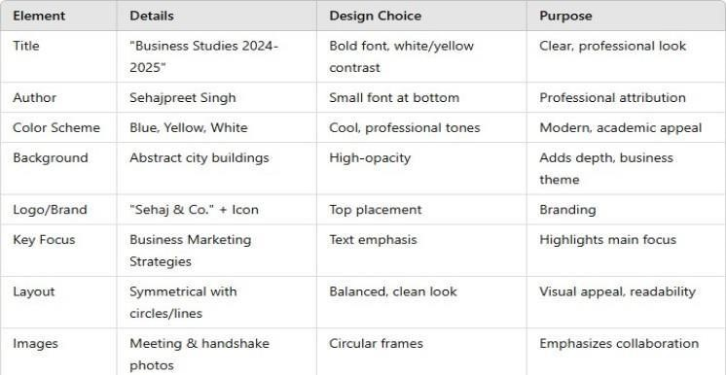

Dataset:

Code fo~~r~~ Experiment/Practical:

Photoshop Tools/~~T~~echniq~~u~~es:



T~~e~~xt Tool for addi~~n~~g the title  and author infor~~m~~ation.S~~h~~ape Tool to create background s~~h~~apes and visual elements.LayerMasking to blend images.



Adjustment La~~y~~ers (l~~i~~ke ~~H~~ue/Saturation) for color correctio~~n~~.Smart Objects to m~~a~~intain image q~~u~~ali~~t~~y while resizing.



Blending Options for shadows or gradients

toenhance textvisibility.



Result/Output:



FRONT COVER:

BACK COVER:



Learning Outcomes (What I have learnt):



1. Prac~~t~~ical applic~~a~~tion of Photoshop tools ~~i~~n designingbookcovers.



1. Importance of visual ~~hi~~erarchy in layou~~t~~ design.



1. Combining typography and imagery tocommuni~~c~~ate ~~a~~th~~e~~meeffe~~c~~tively.
2. Working with color pale~~t~~tes to ~~c~~re~~a~~te a c~~o~~he~~s~~ive andprofessional ~~d~~esign.



1. Expor~~t~~ing high-~~r~~esol~~u~~tion files for print prod~~u~~ction.